Problem Statement:

1. Which is the best country to find new talent?
2. How important is the result in qualifying for the race? (In general and for each track).
3. How does the result in the sprint race affect the result in the race?
4. What is the correlation between the average lap time and fastest lap of a winner and the result of the race?

Queries:

1)

-Total victories per nationality

SELECT DISTINCT d.nationality, SUM(r.position) AS 'Total victories'

FROM drivers d

JOIN results r ON d.driverId = r.driverId

WHERE r.position = 1

GROUP BY d.nationality

ORDER BY SUM(r.position) DESC

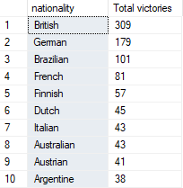total rows = 23

-Races with points per nationality

SELECT DISTINCT d.nationality, COUNT(r.position) AS 'Races with points'

FROM drivers d

JOIN results r ON d.driverId = r.driverId

WHERE r.position >= 10

GROUP BY d.nationality

ORDER BY COUNT(r.position) DESC

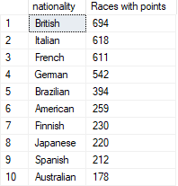total rows = 40

-Drivers nationality percentage

SELECT nationality, cant, CONCAT(CAST((cant * 1.0 / total_cant) * 100 AS DECIMAL(10,2)), '%') AS percentage

FROM (SELECT d.nationality, COUNT(*) AS cant, (SELECT COUNT(*) FROM drivers) AS total_cant

FROM drivers d

GROUP BY d.nationality) AS subquery

ORDER BY cant DESC;

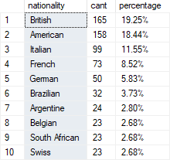total rows = 42

-Fastests Laps per Nationality (Ranking first in the race)

SELECT DISTINCT d.nationality, SUM(r.rank) AS 'Total Fastest Laps'

FROM drivers d

JOIN results r ON d.driverId = r.driverId

WHERE r.rank = 1

GROUP BY d.nationality

ORDER BY SUM(r.rank) DESC

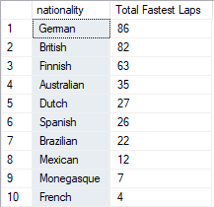total rows = 17